On-Line Registration Instructions/Screenshots
- Log into DukeHub, the link is contained within the online registration email.
- Verify that you have a registration appointment
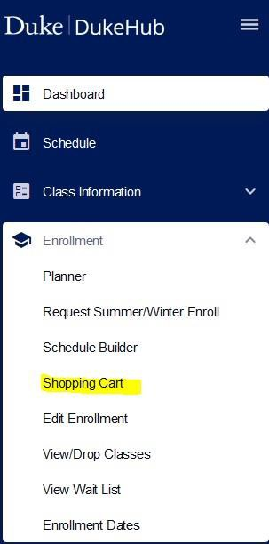
- Select “Enrollment” and then select “Shopping Cart” from the Dashboard.
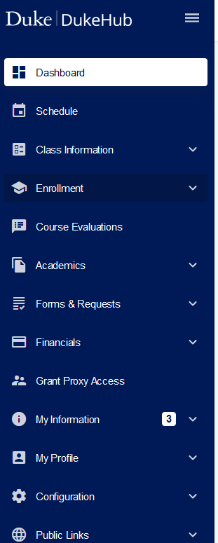

- Select the appropriate Term from the Drop-Down Box

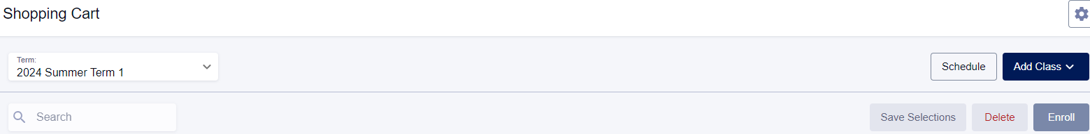

Select “Class Information” from the Dashboard. Select the appropriate term. You may choose to use the Simple Class Search function or the Advanced Class Search – either will work.
You may complete an advanced search directly from the shopping cart by selecting the “Add Class” button on the top right side of the Shopping Cart.

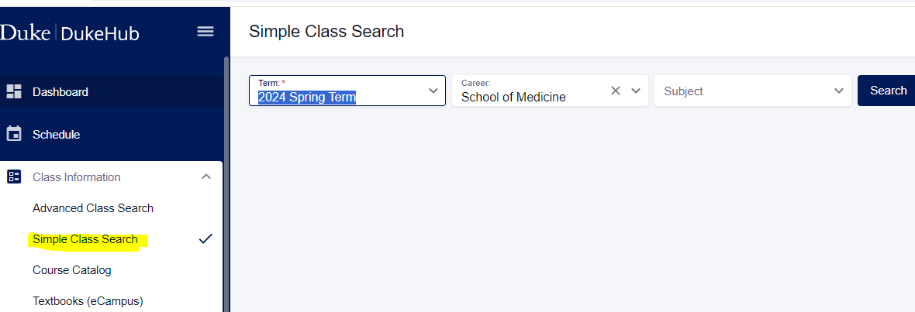

Note: Med 4th Year 1st 8 Weeks contains sections 41 and 42; Med 4th Year 2nd 8 weeks contains sections 43 and 44.

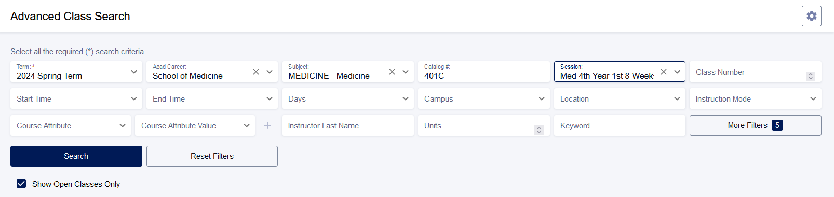
Notice that the box is checked to the right of “Show Open Classes Only”. You may uncheck that if you find it helpful.

If you prefer to use the Simple Class Search option under Class Information, that is also fine. Select the appropriate term and then enter the course subject (i.e., Anesth, Medicine, Dermatol, Emergmed, etc.). and select “Search”

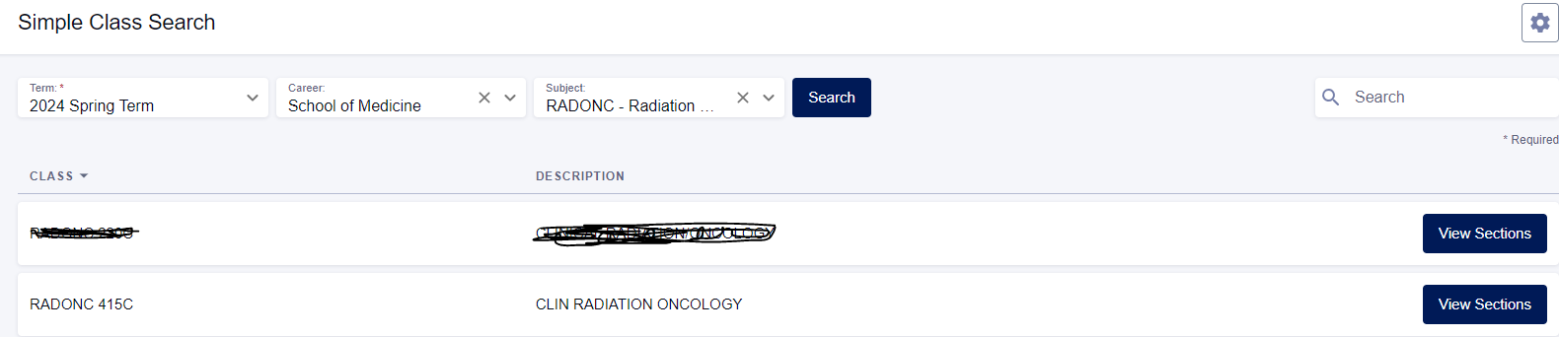
Select “View Sections”

Select the Class and then select “View Sections”

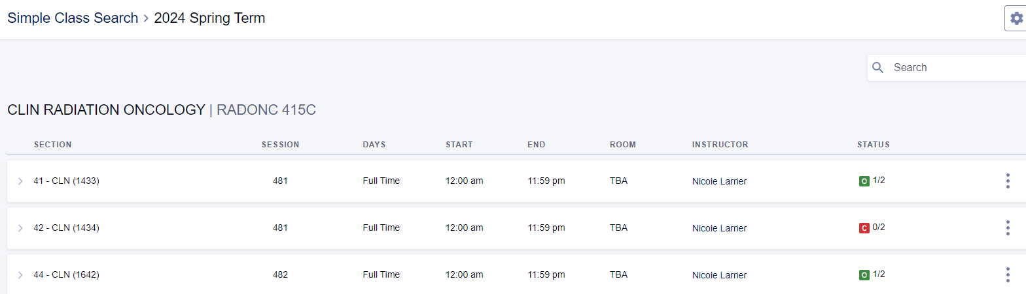

The green “O” indicates the course is open ; the red “C” indicates that it is closed.

When you select the section row – example: 43-CLN, you will be provided with the course description (listed under Information). If permission/consent is required to enroll, it will be noted at the end of the course information. It will look like the following:
Note: INTERDIS 401C does not require permission to enroll
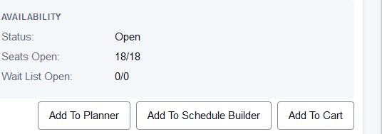
To add the course, please select the “Add to Cart” button at the bottom

IMPORTANT: When you select “add to Cart” the following Enrollment Options box will appear. This box does not mean that the course requires a permission number.
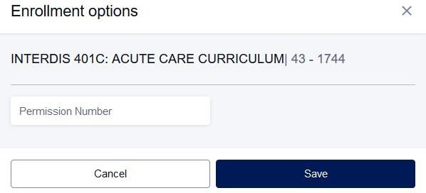

If the course requires a permission number, please add it in the field provided. If the course does NOT require permission of the instructor (please check the course description to confirm), select “Save”. If the course requires permission to enroll, you should receive an error message when you complete the Validation process.
If a course requires a permission number to enroll, please contact the course director or the contact noted in the course description. The Registrar’s Office cannot provide permission numbers.
After selecting “Save”, the course will be added to the Shopping Cart. Please view your shopping cart.

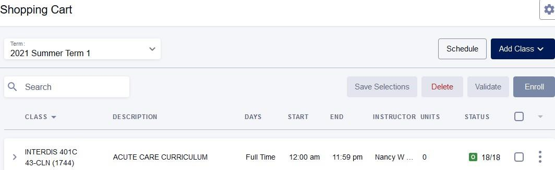

select

  - Select and Validate courses in your shopping cart.
  - When you select “validate”, you should receive message that the course is ok to add. If there is a requirement missing, you will receive an error message when you validate.
  - After validating and receiving the okay to add message, you should be ready when registration opens

  - To complete the enrollment process, after online registration opens, make sure that you are on the Shopping cart page; then select the “Enroll” button when registration opens. If you try to enroll before the online registration opens, you will receive an error message saying you do not have permission to enroll. That means registration hasn’t opened. It does not necessarily mean you have to have a permission number to enroll. Please check the course descriptions (course information) via DukeHub and check the registration email for the open and close dates/times for online registration.

Included below is an example of course that requires a permission number/consent: Medicine 401C (this is what you would see when you select the course, (the arrow “>” to the left of the class subject/course number and section):

Information
Class Number: 1810 Career: School of Medicine
Session: Med 4th Year 2nd 8 Weeks Units: 5 units
Grading: Pass, High Pass, Honors, Fail Description:
Course Goals: To provide an internal medicine inpatient care experience at the intern level. (2) How Goals Are Achieved: Students are assigned to an inpatient service at Duke or the Durham VA.....

Add Consent: Instructor Consent Required
Drop Consent: Instructor Consent Required

Do not hesitate to contact the School of Medicine Registrar’s Office, medreg@dm.duke.edu, if you have questions about the online registration process or if we may be of assistance.

