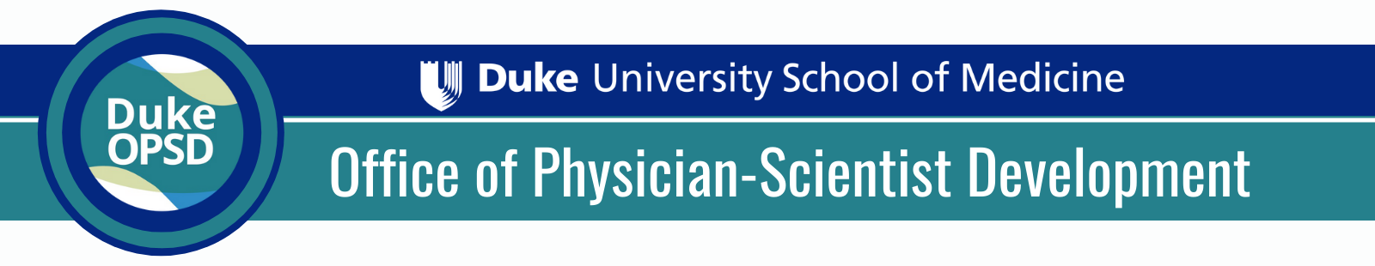

OPSD Technician Support
Memorandum of Understanding
The purpose of this memorandum of understanding (MOU) is to assure that financial resources are available and can be committed to fully support the laboratory technician/research assistant who will be partially supported by the funds obtained through this Research Technician Support Award.

Mission of the Technician Support Program:
The primary mission of the OPSD Research Technician Support Initiative is as follows:
- Enhance research productivity of early career physician-scientists by providing funding to support a portion of effort of a laboratory technician or research assistant to be dedicated to the applicants research project.
- Promote continuity of early physician-scientists’ research trajectory and scientific impact
- Foster a pipeline of students interested in working as research technicians, while pursuing their own careers in biomedical sciences

Program Structure:
The Duke Office of Physician-Scientists Development (OPSD) is committed to funding each awardee with $25,000 for 1 year to cover a portion of the salary and associated fringe benefits of a laboratory technician or research assistant. This award is renewable for an additional year with demonstrated success in year 1 and a need for year 2. Two award options are available for OPSD RFA applicants and must be decided at the time of application (budget details found in RFA section IV).
The OPSD has engaged the Duke Pre-Health program and the Duke Master of Biomedical Sciences program to assist in identifying exceptional students and early career trainees who are interested in working as technicians and we encourage all applicants to contact the OPSD (opsd@dm.duke.edu) to learn about the opportunity to hire a student or early grad as a technician for their project.

Expectations for applicants (Please initial to show your understanding and agreement below):
_____Technician support covered under this award must be provided for a single person
_____Technician must be hired with a start date no more than 3 months following Notice of Award
_____Allocation of funds to cover technician salary must be complete by June 30, 2021. No-cost extensions are not allowed
_____Agree to provide the OPSD with the CV and name of the person to be covered by the Award within 3 months of the Notice of Award
_____Agree to submit a detailed written report 12 months after the conclusion of the funding period and provide any additional information requested by the OPSD related to this Award.

Expectations for Mentor/PI (Please initial to show your understanding below):
_____Confirm that you have reviewed the applicant’s proposal and that you support both their research proposal and plan for technical support.
_____Confirm that you will provide guidance toward effective hiring (if applicable), HR, management, and delegation responsibilities relative to the applicant and the technician supported by this Award.
_____Confirm that the effort paid for by this Award will be dedicated solely to the applicant’s research project.
_____Confirm that you have projects to which the remaining effort of the technician will be dedicated.
_____Confirm that you are committed to, and have resources for (as indicated in the table below), covering the remainder of the technician’s effort (salary and fringe) over the period of the award.
Please complete funding source information on page 2

Please indicate the source(s) of funding available to cover the remainder of the technician’s salary and fringe not covered by this Award. If other PIs will be covering portions of effort, please include their name with the funding source.
Funding Source (e.g., grant number, divisional funds, etc) | Name of Project | End Date  (if applicable)

Applicant Name |  | Applicant Signature |  | Date
Mentor/PI Name |  | Mentor/PI Signature |  | Date

MORE INFORMATION
For additional information on this funding opportunity, please contact opsd@dm.duke.edu

