CoreResearch@Duke
Core User
Notifications User Guide
08/08/18
Version 1.0

Table of Contents
Notifications (E-mails from CoreResearch@Duke) 3
Configuring Core E-mail Notifications 3
Core Notifications Detail tab 4
Notification Inclusion Detail Tab 4

Notifications (E-mails from CoreResearch@Duke)
You can specify which e-mails you would like to receive from CoreResearch@Duke through the User Preferences.
To update your notification preferences,
1. Select your initials form the upper right corner and click Change Preferences
2. Click the Notification Inclusions detail tab
3. Click Add New
4. Select the checkbox next to the notifications that you want to receive.
5. Click Select & Return
6. Click Save
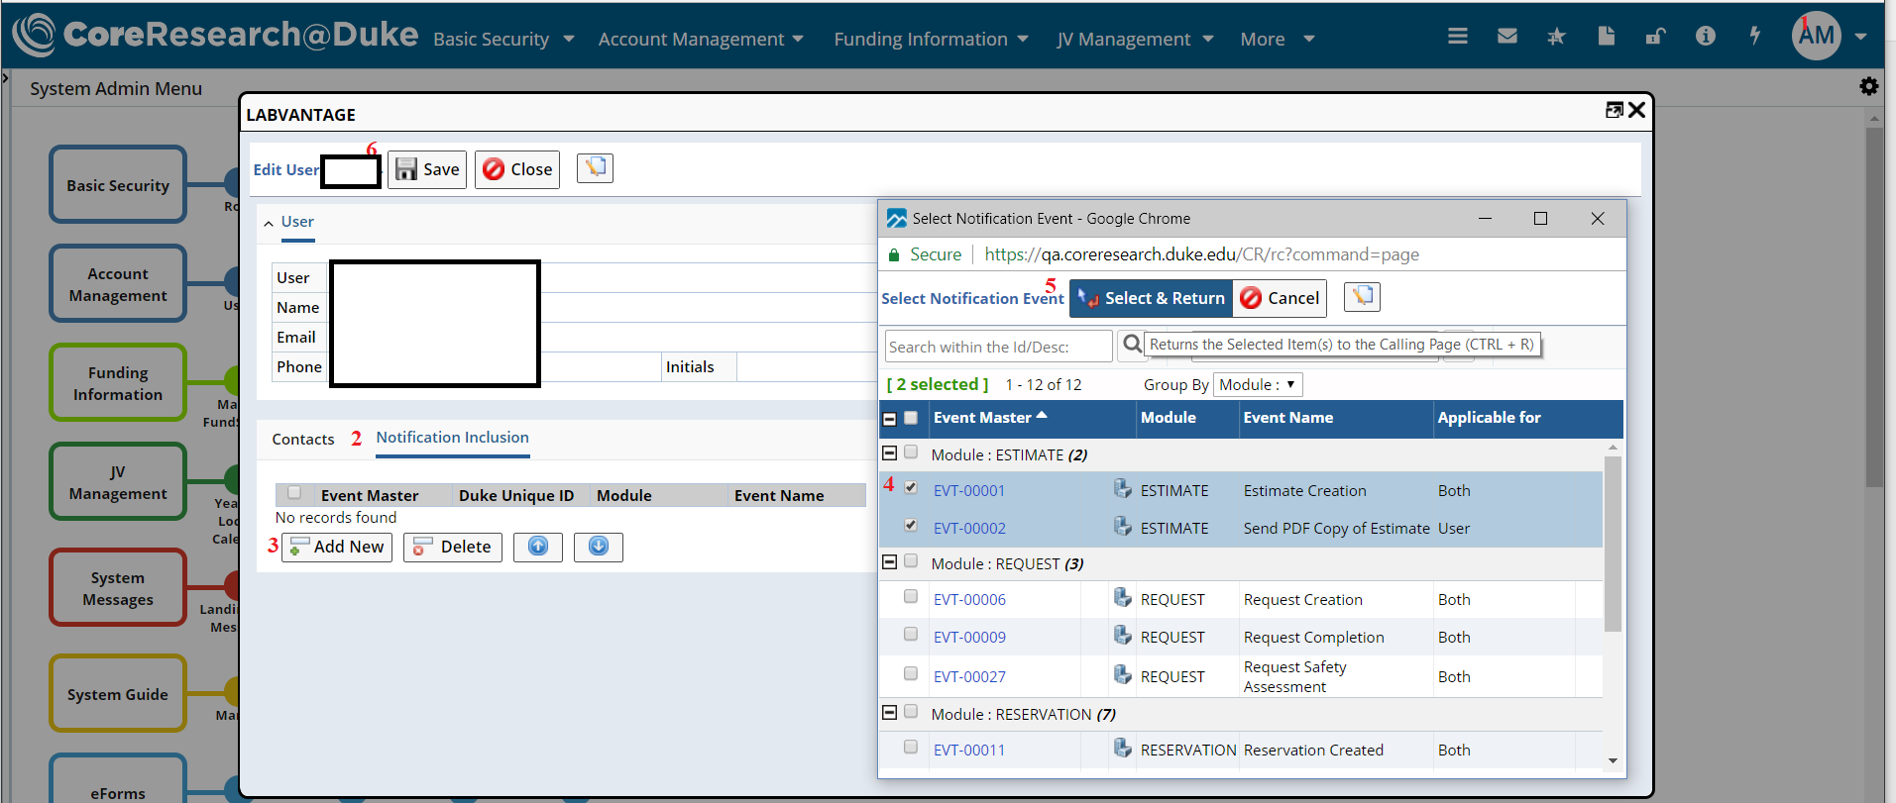

Configuring Core E-mail Notifications
Core E-mail notifications are configured on the LabAdmin sitemap through the Cores & Biobanks tramstop on the Account Management tramline.
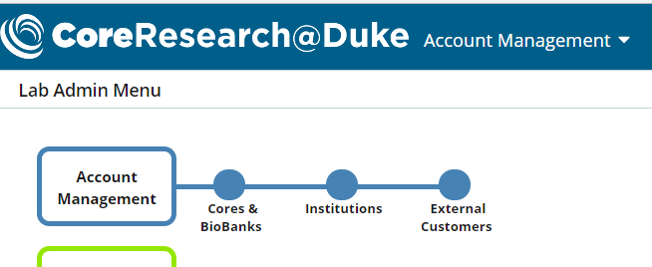

Core Notifications Detail tab
This tab allows Cores to define which Notifications are sent to users by the Core. Note: users will only receive these e-mails if they opt in to that e-mail.
1. Select the Core Notification tab
2. Select Add New
3. Check the check box next to notfications you want the Core to send.
4. Click select & Return
5. Click Save
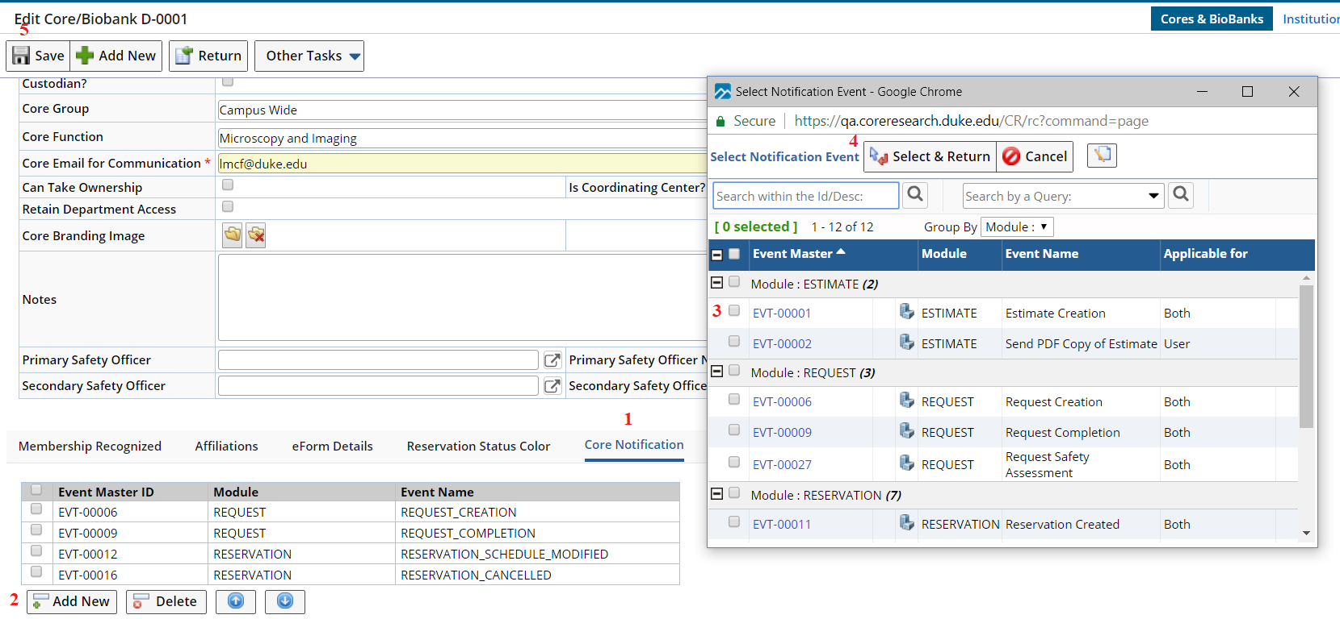

Notification Inclusion Detail Tab
The Notification Inclusion detail tab allows the Core to select which e-mails the Core e-mail address receives.
1. Select the Notification Inclusion detail tab.
2. Click Add New
3. Select the checkbox next to the notifications you want the Core e-mail to receive.
4. Click Select & Return.
5. Click Save.
