Duke Medicine

CoreResearch@Duke
Reports
User Guide
5/20/16
Version 1.0

Contents
Target Audiences 4
Report Parameters 4
Output To: This is where you want to view the report, either on your computer screen or sent to your email. 4
Output Format: The available output formats are PDF or Excel 4
Report Arguments: 4
Reports Location 4
SR Activity by Core (Shared Resources Activity by Core) 5
SR Financial Details (Shared Resources Financial Details) 6
SR Instr Resv Det R (Shared Resources Instrument Reservation Details) 7
SR Instr Resv Detail (Shared Resources Instrument Reservation Details) 7
SR Instr Resv Org Su (Shared Resources Instrument Reservation Organization Summary) 8
SR Instr Resv PI Sum (Shared Resources Instrument Reservation PI Summary) 9
SR Inst Resv Summ (Shared Resources Instrument Reservation Summary) 10
SR Invoice Details (Shared Resources Invoice Details) 10
SR Invoice Summ FA (Shared Resources Invoice Summary Financial Administrator) 11
SR Invoice Summ Fund (Shared Resources Invoice Summary Fund) 12
SR Invoice Summ PI (Shared Resources Invoice Summary by PI) 12
SR Invoice Summary (Shared Resources Invoice Summary) 13
SR Invoice Svc Membership Summary (Shared Resources Invoice Services Membership Summary and/or Affilations) 14
SR Invoice Svc OrgUnit Summary (Shared Resources Invoice Services Organization Unit Summary) 15
SR Invoice Svc PI Summary (Shared Resources Invoice Services PI Summary) 16
SR Invoice Svc Summ (Shared Resources Invoice Services Summary) 17
SR Job Details (Shared Resources Job Details) 18
SR PI Users Projects (Shared Resources PI Users Projects) 19
SR Resv Org Summ (Shared Resources Reservation Organization Summary) 20
SR Session Details (Shared Resources Session Details) 21
Summary Invoice 22
SummaryInvoiceByCore 23
Service Task Rate MA 24
User Connection Log 25
Appendix 27
Reports Applicable for Core Personnel 27
Reports Applicable for Principal Investigators and PI-Delegates 27
Reports Applicable for Financial Managers 27

Target Audiences
This document was written to support the activities for the following CoreResearch@Duke (CR@D) job types: Core Director, Core Manager, Core Staff, Core Financial Manager, Financial Administrator, Principal Investigator, and Principal Investigator Delegate.
The reports are security based and what displays when you run the report, is dependent upon the role you have, fund codes you are associated with, and your core(s).

Report Parameters

Output To: This is where you want to view the report, either on your computer screen or sent to your email.

Output Format: The available output formats are PDF or Excel
Report Arguments: The report arguments that are highlighted in yellow are required fields. The arguments that are not highlighted in yellow are optional.

Reports Location
Reports can be accessed from the LIMS sitemap. The ‘Execute Reports’ tramline is located on the Reports tramline.
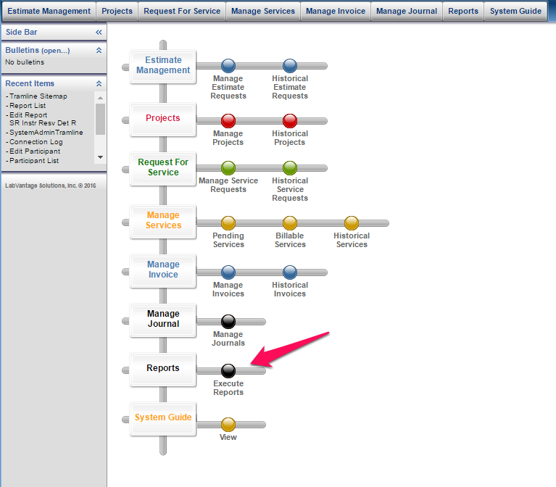

SR Activity by Core (Shared Resources Activity by Core)
Intended Audience: Core Director, Core Manager, Core Staff, Core Financial Manager, Financial Administrator
Short Description: The SR Activity by Core report lists all reservation activity by core. This is a raw data output report.
Instructions:
- Select the report you want to run
- Click the ‘Run Report’ icon
- Select Output preference to view on local window or to be emailed
- Select Output Format PDF or Excel
- Enter an Activity Start Date (Required)
- Enter an Activity End Date (Required)
- Enter a Core (Optional; the default is the cores you have access to. (Select individual cores to restrict returned results.)
- Affiliation (Optional; this includes all affiliations by default. Select individual affiliations to restrict returned results.)
- Select Run Report.
Example (in Excel format):
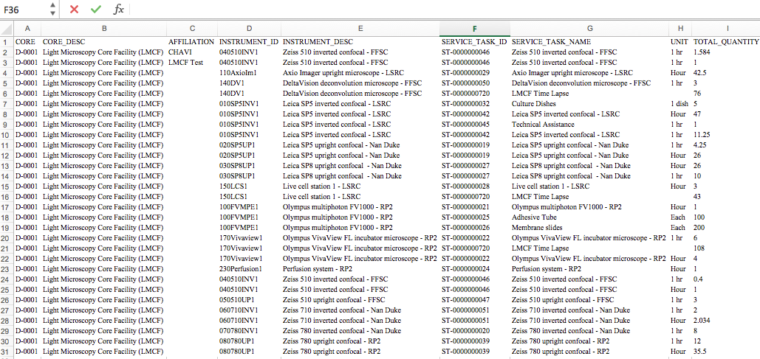

SR Financial Details (Shared Resources Financial Details)
Intended Audience: Core Director, Core Manager, Core Staff, Core Financial Manager, Financial Administrator
Short Description: The SR Financial Details report lists all financial details. This is a raw data output report.
Instructions:
- Select the report you want to run
- Click the ‘Run Report’ icon
- Select Output preference to view on local window or to be emailed
- Select Output Format PDF or Excel
- Enter an Invoice Start Date (Required)
- Enter an Invoice End Date (Required)
- Enter a Core (Optional; the default is the cores you have access to. (Select individual cores to restrict returned results.)
- Enter an Instrument (Optional)
- Enter a Service Task (Optional)
- Affiliation (Optional; this includes all affiliations by default. Select individual affiliations to restrict returned results.)
- Membership (Optional)
- PI (Optional)
- Project (Optional)
- Invoice Status (Optional)
- Select Run Report.
Example (in Excel format):
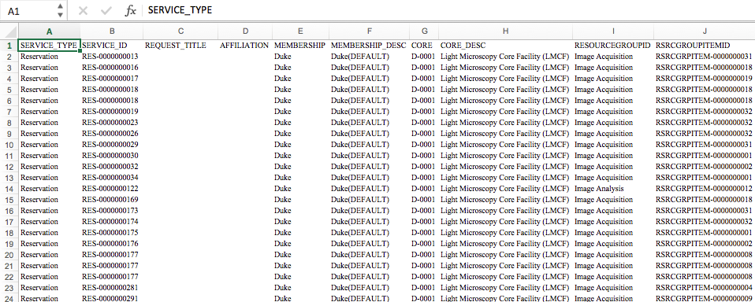

SR Instr Resv Det R (Shared Resources Instrument Reservation Details)
Intended Audience: Core Director, Core Manager, Core Staff, Core Financial Manager, Financial Administrator
Short Description: The SR Instr Resv Det R report lists the actual usage hours for a core by instrument. This is a raw data output report.
Instructions:
- Select the report you want to run
- Click the ‘Run Report’ icon
- Select Output preference to view on local window or to be emailed
- Select Output Format PDF or Excel
- Enter a Start Date (Required)
- Enter an End Date (Required)
- PI (Optional)
- Select Run Report.
Example (in Excel format):
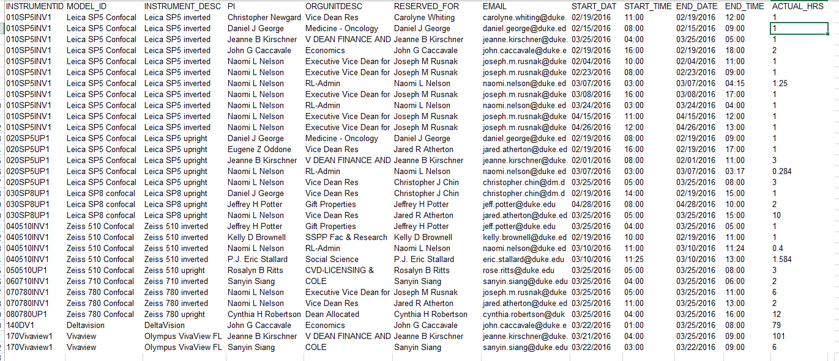

SR Instr Resv Detail (Shared Resources Instrument Reservation Details)
Intended Audience: Core Director, Core Manager, Core Staff, Core Financial Manager, Financial Administrator
Short Description: The SR Instr Resv Detail report lists all financial details. This is a formatted data output for PDF report.
Instructions:
- Select the report you want to run
- Click the ‘Run Report’ icon
- Select Output preference to view on local window or to be emailed
- Select Output Format PDF or Excel
- Enter a Start Date (Required)
- Enter an End Date (Required)
- PI (Optional)
- Select Run Report.
Example (in PDF format):
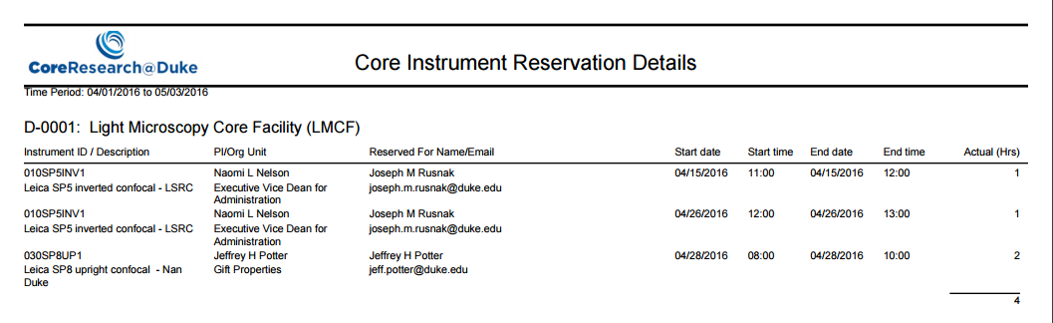

SR Instr Resv Org Su (Shared Resources Instrument Reservation Organization Summary)
Intended Audience: Core Director, Core Manager, Core Staff, Core Financial Manager, Financial Administrator
Short Description: The SR Instr Resv Org Su report lists actual usage hours for an organization by instrument. This is a formatted data output report intended for PDF.
Instructions:
- Select the report you want to run
- Click the ‘Run Report’ icon
- Select Output preference to view on local window or to be emailed
- Select Output Format PDF
- Enter a Start Date (Required)
- Enter an End Date (Required)
- Select Run Report.
Example (in PDF format):
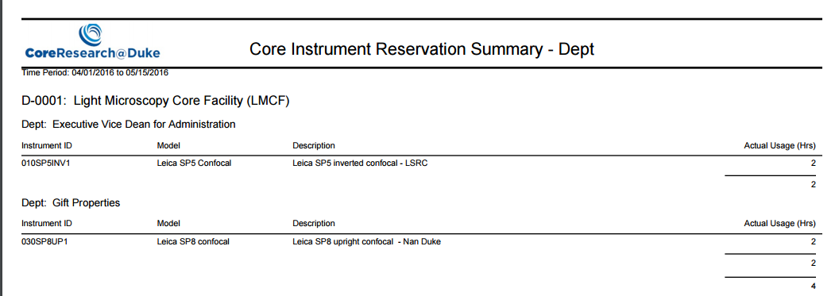

SR Instr Resv PI Sum (Shared Resources Instrument Reservation PI Summary)
Intended Audience: Core Director, Core Manager, Core Staff, Core Financial Manager, Financial Administrator
Short Description: The SR Instr Resv PI Sum report lists actual usage hours for a selected PI(s) by core.
Instructions:
- Select the report you want to run
- Click the ‘Run Report’ icon
- Select Output preference to view on local window or to be emailed
- Select Output Format PDF or Excel
- Enter a Start Date (Required)
- Enter an End Date (Required)
- PI (Optional)
- Select Run Report.
Example (in PDF format):
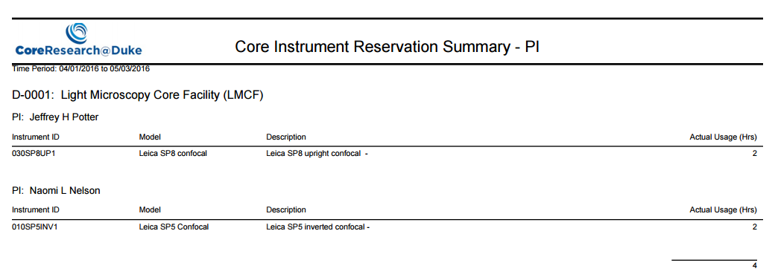

SR Inst Resv Summ (Shared Resources Instrument Reservation Summary)
Intended Audience: Core Director, Core Manager, Core Staff, Core Financial Manager, Financial Administrator
Short Description: The SR Instr Resv Summ lists actual usage hours per instrument, per core.
Instructions:
- Select the report you want to run
- Click the ‘Run Report’ icon
- Select Output preference to view on local window or to be emailed
- Select Output Format PDF or Excel
- Enter a Start Date (Required)
- Enter an End Date (Required)
- Select Run Report.
Example (in PDF format):
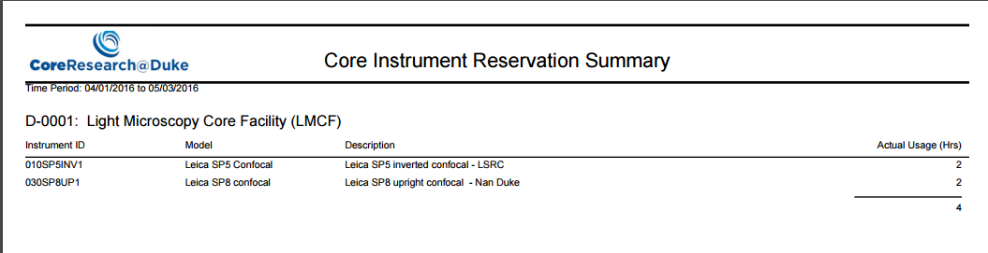

SR Invoice Details (Shared Resources Invoice Details)
Intended Audience: Core Director, Core Manager, Core Staff, Core Financial Manager, Financial Administrator
Short Description: The SR Invoice Details report lists the Core, Invoice, PI, Invoice Date, Fundcode and Services Details per filtered time period.
Instructions:
- Select the report you want to run
- Click the ‘Run Report’ icon
- Select Output preference to view on local window or to be emailed
- Select Output Format PDF or Excel
- Enter a Start Date (Required)
- Enter an End Date (Required)
- PI (Optional)
- Project (Optional)
- Select Run Report.
Example (in Excel format):

SR Invoice Summ FA (Shared Resources Invoice Summary Financial Administrator)
Intended Audience: Core Director, Core Manager, Core Staff, Core Financial Manager, Financial Administrator
Short Description: The SR Invoice Summ FA report lists the top 20 Users of the core by PI and amounts. It is a report that can be utilized by a financial administrator, but is available for all core personnel.
Instructions:
- Select the report you want to run
- Click the ‘Run Report’ icon
- Select Output preference to view on local window or to be emailed
- Select Output Format PDF or Excel
- Enter a Start Date (Required)
- Enter an End Date (Required)
- Select Run Report
Example (in PDF format):
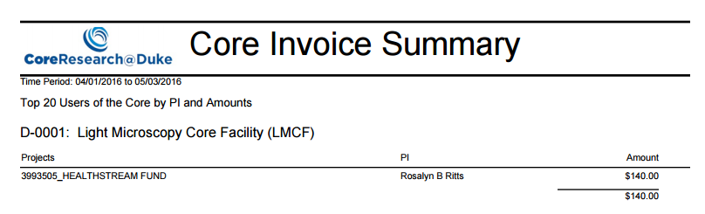

SR Invoice Summ Fund (Shared Resources Invoice Summary Fund)
Intended Audience: Core Director, Core Manager, Core Staff, Core Financial Manager, Financial Administrator
Short Description: The SR Invoice Summ Fund lists all Fund invoicing totals.
Instructions:
- Select the report you want to run
- Click the ‘Run Report’ icon
- Select Output preference to view on local window or to be emailed
- Select Output Format PDF or Excel
- Enter a Start Date (Required)
- Enter an End Date (Required)
- Enter a Core (Optional; the default is the cores you have access to. (Select individual cores to restrict returned results.)
- PI (Optional)
- Project (Optional)
- Select Run Report.
Example (in PDF format):
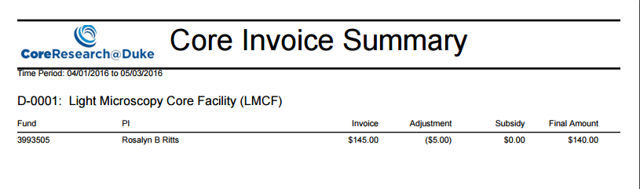

SR Invoice Summ PI (Shared Resources Invoice Summary by PI)
Intended Audience: Core Director, Core Manager, Core Staff, Core Financial Manager, Financial Administrator
Short Description: The SR Invoice Summ PI lists all cores with PI name and Invoice totals.
Instructions:
- Select the report you want to run
- Click the ‘Run Report’ icon
- Select Output preference to view on local window or to be emailed
- Select Output Format PDF or Excel
- Enter a Start Date (Required)
- Enter an End Date (Required)
- PI (Optional)
- Select Run Report.
Example (in PDF format):

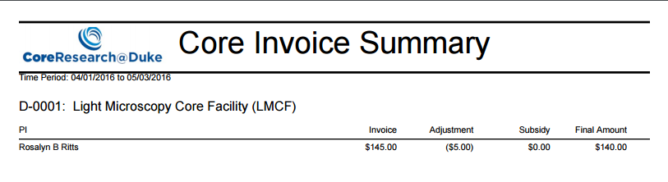

SR Invoice Summary (Shared Resources Invoice Summary)
Intended Audience: Core Director, Core Manager, Core Staff, Core Financial Manager, Financial Administrator
Short Description: The SR Invoice Summary lists all invoices for a core with details.
Instructions:
- Select the report you want to run
- Click the ‘Run Report’ icon
- Select Output preference to view on local window or to be emailed
- Select Output Format PDF or Excel
- Enter a Start Date (Required)
- Enter an End Date (Required)
- PI (Optional)
- Project (Optional)
- Select Run Report.
Example (in PDF format):
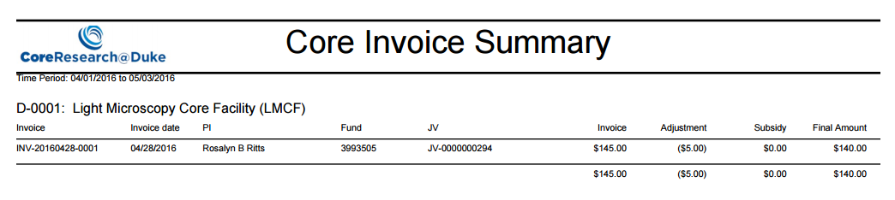

SR Invoice Svc Membership Summary (Shared Resources Invoice Services Membership Summary and/or Affilations)
Intended Audience: Core Director, Core Manager, Core Staff, Core Financial Manager, Financial Administrator
Short Description: The SR Invoice Svc Membership Summary lists the core, their membership and affiliation and the associated service task.
Instructions:
- Select the report you want to run
- Click the ‘Run Report’ icon
- Select Output preference to view on local window or to be emailed
- Select Output Format PDF or Excel
- Enter a Start Date (Required)
- Enter an End Date (Required)
- Enter a Core (Optional; the default is the cores you have access to. (Select individual cores to restrict returned results.)
- Membership (Optional)
- Affiliation (Optional; this includes all affiliations by default. Select individual affiliations to restrict returned results.)
- Select Run Report.
Example (in PDF format):
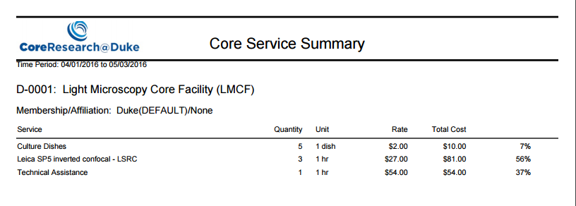

SR Invoice Svc OrgUnit Summary (Shared Resources Invoice Services Organization Unit Summary)
Intended Audience: Core Director, Core Manager, Core Staff, Core Financial Manager, Financial Administrator
Short Description: The SR Invoice Svc OrgUnit Summary lists the core and department with the services they used.
Instructions:
- Select the report you want to run
- Click the ‘Run Report’ icon
- Select Output preference to view on local window or to be emailed
- Select Output Format PDF or Excel
- Enter a Start Date (Required)
- Enter an End Date (Required)
- Enter a Core (Optional; the default is the cores you have access to. (Select individual cores to restrict returned results.)
- Select Run Report.
Example (in PDF format):
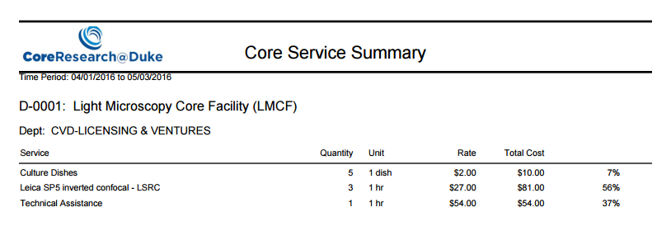

SR Invoice Svc PI Summary (Shared Resources Invoice Services PI Summary)
Intended Audience: Core Director, Core Manager, Core Staff, Core Financial Manager, Financial Administrator
Short Description: The SR Invoice Svc PI Summary pulls one or all the PI’s for the selected time period, for all cores, and lists the department/organization and the services that they have used as a percentage.
Instructions:
- Select the report you want to run
- Click the ‘Run Report’ icon
- Select Output preference to view on local window or to be emailed
- Select Output Format PDF or Excel
- Enter a Start Date (Required)
- Enter an End Date (Required)
- PI (Optional)
- Enter a Core (Optional; the default is the cores you have access to. (Select individual cores to restrict returned results.)
- Select Run Report.
Example (in PDF format):
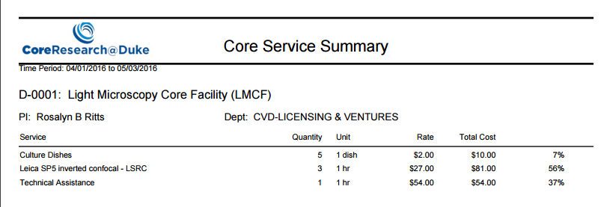

SR Invoice Svc Summ (Shared Resources Invoice Services Summary)
Intended Audience: Core Director, Core Manager, Core Staff, Core Financial Manager, Financial Administrator
Short Description: The SR Invoice Svc Summ lists service tasks by core running report and the cost and percentage of totals.
Instructions:
- Select the report you want to run
- Click the ‘Run Report’ icon
- Select Output preference to view on local window or to be emailed
- Select Output Format PDF or Excel
- Enter a Start Date (Required)
- Enter an End Date (Required)
- Enter a Core (Optional; the default is the cores you have access to. (Select individual cores to restrict returned results.)
- Select Run Report.
Example (in PDF format):
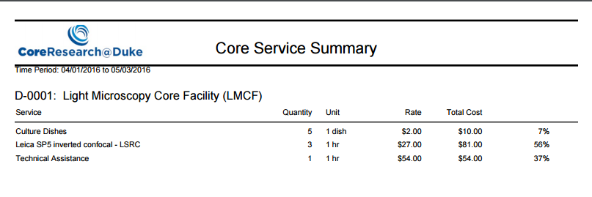

SR Job Details (Shared Resources Job Details)
Intended Audience: Core Director, Core Manager, Core Staff, Core Financial Manager, Financial Administrator
Short Description: The SR Job Details lists all the financial details for service tasks and reservations. This is intended for a raw data output to Excel.
Instructions:
- Select the report you want to run
- Click the ‘Run Report’ icon
- Select Output preference to view on local window or to be emailed
- Select Output Format PDF or Excel
- Enter an Invoice Start Date (Required)
- Enter an Invoice End Date (Required)
- Enter a Service Task (Optional)
- Enter a Core (Optional; the default is the cores you have access to. (Select individual cores to restrict returned results.)
- PI (Optional)
- Operator (Optional)
- Select Run Report.
Example (in Excel format):
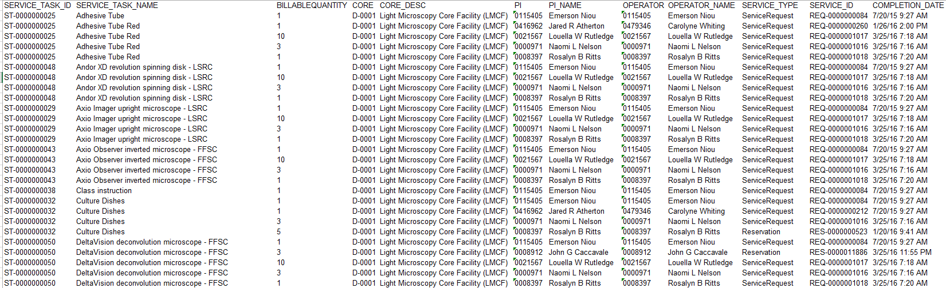

SR PI Users Projects (Shared Resources PI Users Projects)
Intended Audience: Core Director, Core Manager, Core Staff, Core Financial Manager, Financial Administrator, Principal Investigator, Principal Investigator Delegate
Short Description: The SR PI Users Projects report lists PI’s, their associated facility users, their fund sources, and details, their project members and the fund code they are associated on.
Instructions:
- Select the report you want to run
- Click the ‘Run Report’ icon
- Select Output preference to view on local window or to be emailed
- Select Output Format PDF or Excel
- PI (Optional)
- Select Run Report.
Example (in PDF format):
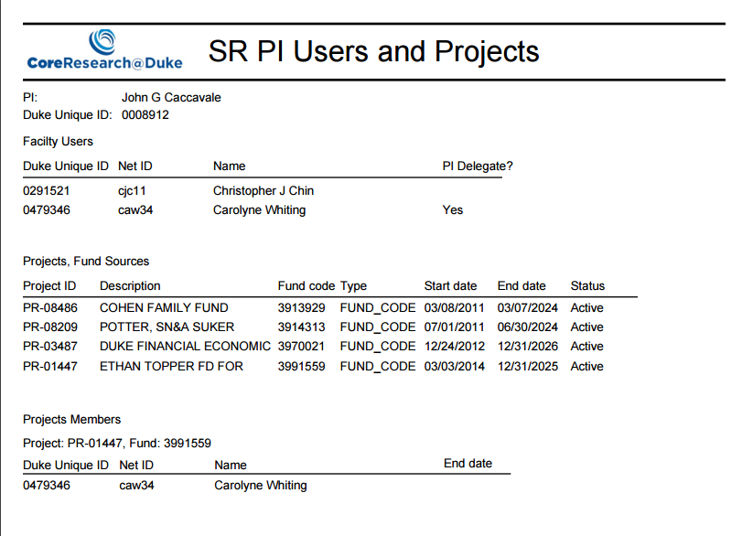

SR Resv Org Summ (Shared Resources Reservation Organization Summary)
Intended Audience: Core Director, Core Manager, Core Staff, Core Financial Manager, Financial Administrator
Short Description: The SR Resv Org Summ report provides a count of the total number of reservations per department by core.
Instructions:
- Select the report you want to run
- Click the ‘Run Report’ icon
- Select Output preference to view on local window or to be emailed
- Select Output Format PDF or Excel
- Enter a Start Date (Required)
- Enter an End Date (Required)
- Select Run Report.
Example (in PDF format):
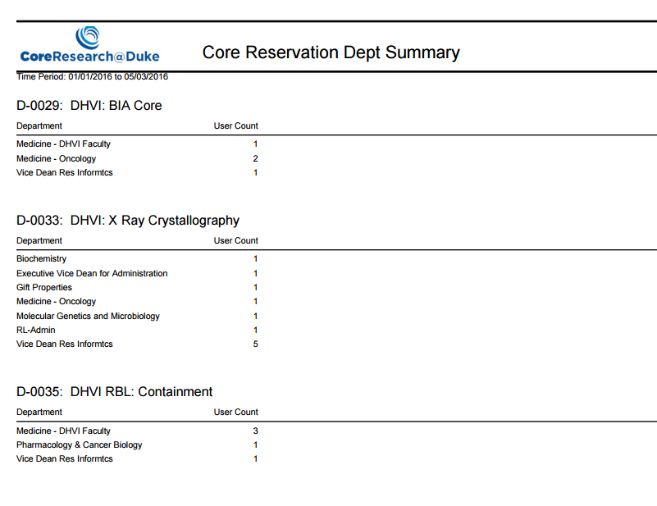

SR Session Details (Shared Resources Session Details)
Intended Audience: Core Director, Core Manager, Core Staff, Core Financial Manager, Financial Administrator
Short Description: The SR Session Details report lists all the reservation details including actual hours. No financial information. This is a raw data export intended for Excel.
Instructions:
- Select the report you want to run
- Click the ‘Run Report’ icon
- Select Output preference to view on local window or to be emailed
- Select Output Format PDF or Excel
- Enter an Actual Start Date (Required)
- Enter an Actual End Date (Required)
- Enter a Service Task (Optional)
- Enter an Instrument (Optional)
- Enter a Core (Optional; the default is the cores you have access to. (Select individual cores to restrict returned results.)
- PI (Optional)
- Reserved For (Optional)
- Select Run Report.
Example (in Excel format):
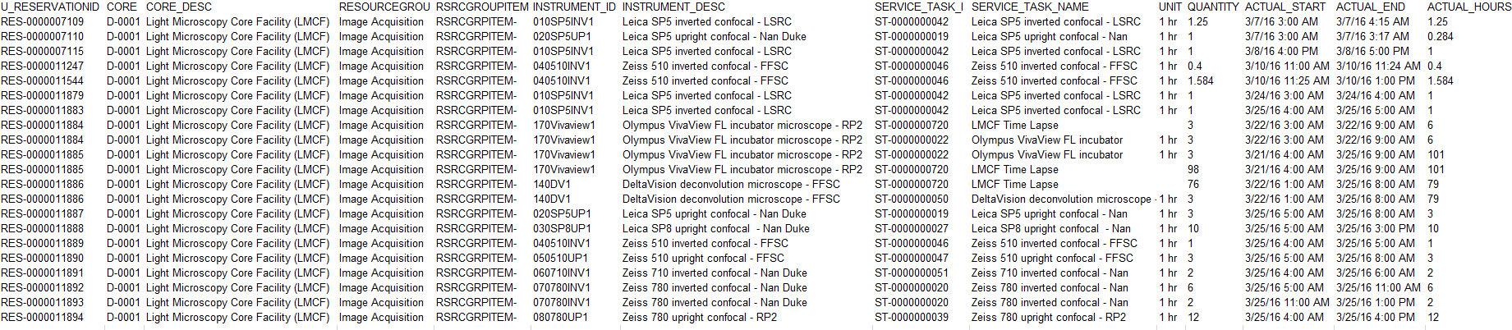

Summary Invoice
Intended Audience: Core Director, Core Manager, Core Staff, Core Financial Manager, Financial Administrator
Short Description: The SummaryInvoice report lists all invoices per selected PI, for all cores, for the time period selected.
Instructions:
- Select the report you want to run
- Click the ‘Run Report’ icon
- Select Output preference to view on local window or to be emailed
- Select Output Format PDF or Excel
- Enter an Invoice Creation Date From(Required)
- Enter an Invoice Creation Date To (Required)
- PI (Required)
- Select Run Report.
Example (in PDF format):
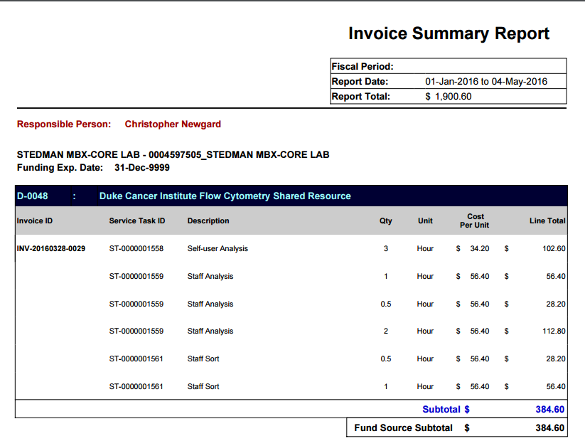

SummaryInvoiceByCore
Intended Audience: Core Director, Core Manager, Core Staff, Core Financial Manager, Financial Administrator
Short Description: The SummaryInvoiceByCore lists all invoices per selected PI for selected core.
Instructions:
- Select the report you want to run
- Click the ‘Run Report’ icon
- Select Output preference to view on local window or to be emailed
- Select Output Format PDF or Excel
- Select a PI from the listpage using the search icon (Required)
- Enter an Invoice Creation Date From (Required)
- Enter an Invoice Creation Date To (Required)
- Select a core from the dropdown (Required)
- Select Run Report.
Example (in PDF format):

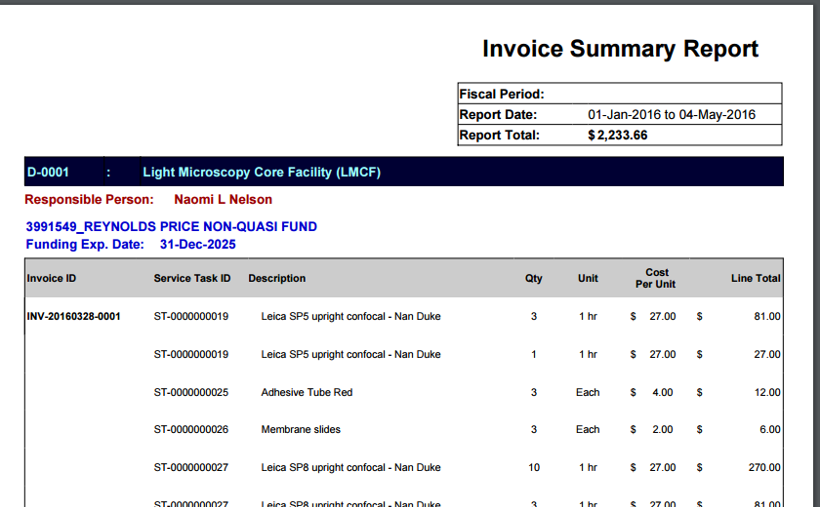

Service Task Rate MA
Intended Audience: Financial Administrators
Short Description: The Service Task Rate MA lists all service tasks for each membership/affiliation.
Instructions:
- Select the report you want to run
- Click the ‘Run Report’ icon
- Select Output preference to view on local window or to be emailed
- Select Output Format PDF or Excel
- Select a Membership from the dropdown (optional)
- Select an Affiliation from the dropdown (optional)
- Select Run Report.
Example (in PDF format):
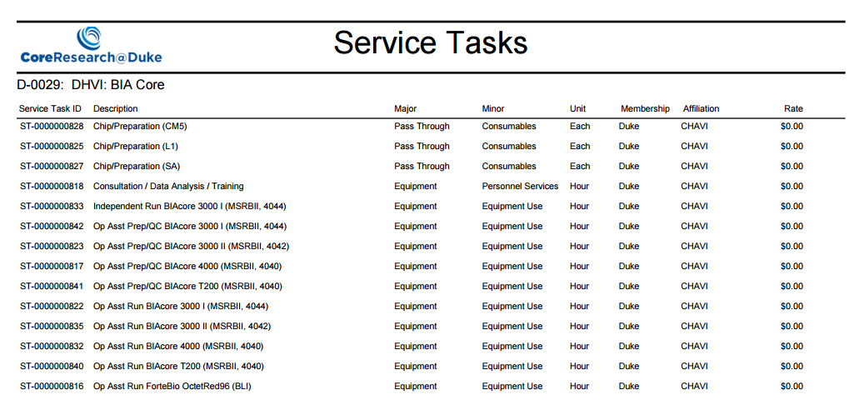

User Connection Log
Intended Audience: Financial Administrator
Short Description: The User Connection Log displays users who have logged in for the selected date range, displaying their netid and email address.

Instructions:
- Select the report you want to run
- Click the ‘Run Report’ icon
- Select Output preference to view on local window or to be emailed
- Select Output Format PDF or Excel
- Enter a Start Date (Required)
- Enter an End Date (Required)
- Select Run Report.
Example (in Excel format):

Appendix

Reports Applicable for Core Personnel
SR Activity by Core (Shared Resources Activity by Core)
SR Financial Details (Shared Resources Financial Details)
SR Instr Resv Det R (Shared Resources Instrument Reservation Details)
SR Instr Resv Detail (Shared Resources Instrument Reservation Details)
SR Instr Resv Org Su (Shared Resources Instrument Reservation Organization Summary)
SR Instr Resv PI Sum (Shared Resources Instrument Reservation PI Summary)
SR Inst Resv Summ (Shared Resources Instrument Reservation Summary)
SR Invoice Details (Shared Resources Invoice Details)
SR Invoice Summ FA (Shared Resources Invoice Summary Financial Administrator)
SR Invoice Summ Fund (Shared Resources Invoice Summary Fund)
SR Invoice Summ PI (Shared Resources Invoice Summary by PI)
SR Invoice Summary (Shared Resources Invoice Summary)
SR Invoice Svc Membership Summary (Shared Resources Invoice Services Membership Summary and/or Affilations)
SR Invoice Svc OrgUnit Summary (Shared Resources Invoice Services Organization Unit Summary)
SR Invoice Svc PI Summary (Shared Resources Invoice Services PI Summary)
SR Invoice Svc Summ (Shared Resources Invoice Services Summary)
SR Job Details (Shared Resources Job Details)
SR PI Users Projects (Shared Resources PI Users Projects)
SR Resv Org Summ (Shared Resources Reservation Organization Summary)

Reports Applicable for Principal Investigators and PI-Delegates
SR PI Users Projects

Reports Applicable for Financial Managers
SR Activity by Core (Shared Resources Activity by Core)
SR Financial Details (Shared Resources Financial Details)
SR Instr Resv Det R (Shared Resources Instrument Reservation Details)
SR Instr Resv Detail (Shared Resources Instrument Reservation Details)
SR Instr Resv Org Su (Shared Resources Instrument Reservation Organization Summary)
SR Instr Resv PI Sum (Shared Resources Instrument Reservation PI Summary)
SR Inst Resv Summ (Shared Resources Instrument Reservation Summary)
SR Invoice Details (Shared Resources Invoice Details)
SR Invoice Summ FA (Shared Resources Invoice Summary Financial Administrator)
SR Invoice Summ Fund (Shared Resources Invoice Summary Fund)
SR Invoice Summ PI (Shared Resources Invoice Summary by PI)
SR Invoice Summary (Shared Resources Invoice Summary)
SR Invoice Svc Membership Summary (Shared Resources Invoice Services Membership Summary and/or Affilations)
SR Invoice Svc OrgUnit Summary (Shared Resources Invoice Services Organization Unit Summary)
SR Invoice Svc PI Summary (Shared Resources Invoice Services PI Summary)
SR Invoice Svc Summ (Shared Resources Invoice Services Summary)
SR Job Details (Shared Resources Job Details)
SR PI Users Projects (Shared Resources PI Users Projects)
SR Resv Org Summ (Shared Resources Reservation Organization Summary)
Reports Applicable for Financial Administrators
SR Activity by Core (Shared Resources Activity by Core)
SR Financial Details (Shared Resources Financial Details)
SR Instr Resv Det R (Shared Resources Instrument Reservation Details)
SR Instr Resv Detail (Shared Resources Instrument Reservation Details)
SR Instr Resv Org Su (Shared Resources Instrument Reservation Organization Summary)
SR Instr Resv PI Sum (Shared Resources Instrument Reservation PI Summary)
SR Inst Resv Summ (Shared Resources Instrument Reservation Summary)
SR Invoice Details (Shared Resources Invoice Details)
SR Invoice Summ FA (Shared Resources Invoice Summary Financial Administrator)
SR Invoice Summ Fund (Shared Resources Invoice Summary Fund)
SR Invoice Summ PI (Shared Resources Invoice Summary by PI)
SR Invoice Summary (Shared Resources Invoice Summary)
SR Invoice Svc Membership Summary (Shared Resources Invoice Services Membership Summary and/or Affilations)
SR Invoice Svc OrgUnit Summary (Shared Resources Invoice Services Organization Unit Summary)
SR Invoice Svc PI Summary (Shared Resources Invoice Services PI Summary)
SR Invoice Svc Summ (Shared Resources Invoice Services Summary)
SR Job Details (Shared Resources Job Details)
SR PI Users Projects (Shared Resources PI Users Projects)
SR Resv Org Summ (Shared Resources Reservation Organization Summary)
Service Task Rate MA
User Connection Log

